Report 2
Szymon Mańka
Jeremi Szczotka
Piotr Krupiński
Conceptual Model
The diagram presents a high-level conceptual view of the flight delay analysis domain.
The central business object is Flight, which is described by operational, temporal,
geographic, weather-related, and disruption-related elements.
This model is intentionally non-technical.
It does not show database tables, keys, or data types.
Instead, it reflects how we understand the domain and which factors may influence
flight delays and cancellations.
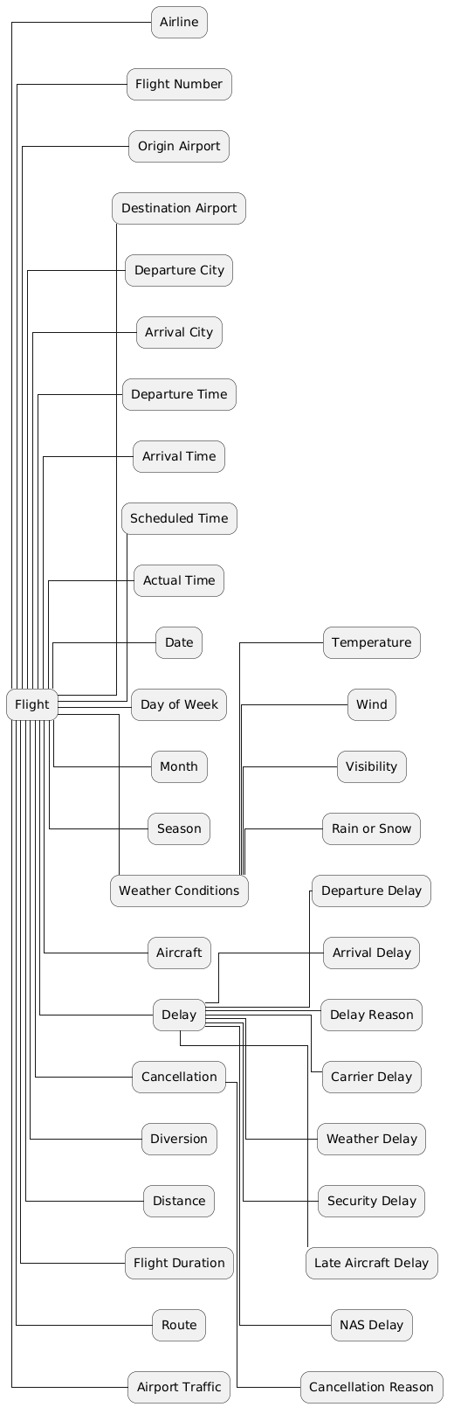
ERD

